Project Design Phase-II
Data Flow Diagram & User Stories
Date | 1 October 2026
Team ID
Project Name | Import Data using Transform Maps (Spreadsheet)
Maximum Marks | 4 Marks
Data Flow Diagrams:
A Data Flow Diagram (DFD) is a traditional visual representation of the information flows within a system. A neat and clear DFD can depict the right amount of the system requirement graphically. It shows how data enters and leaves the system, what changes the information, and where data is stored.
DFD Level 0 (Context Diagram):
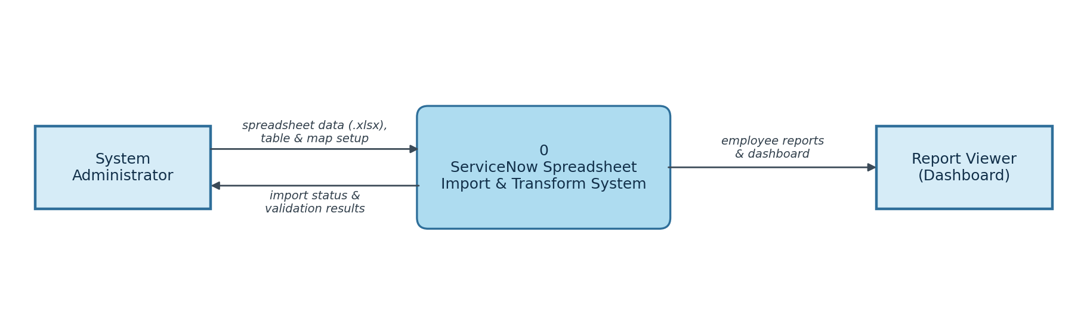

DFD Level 1:
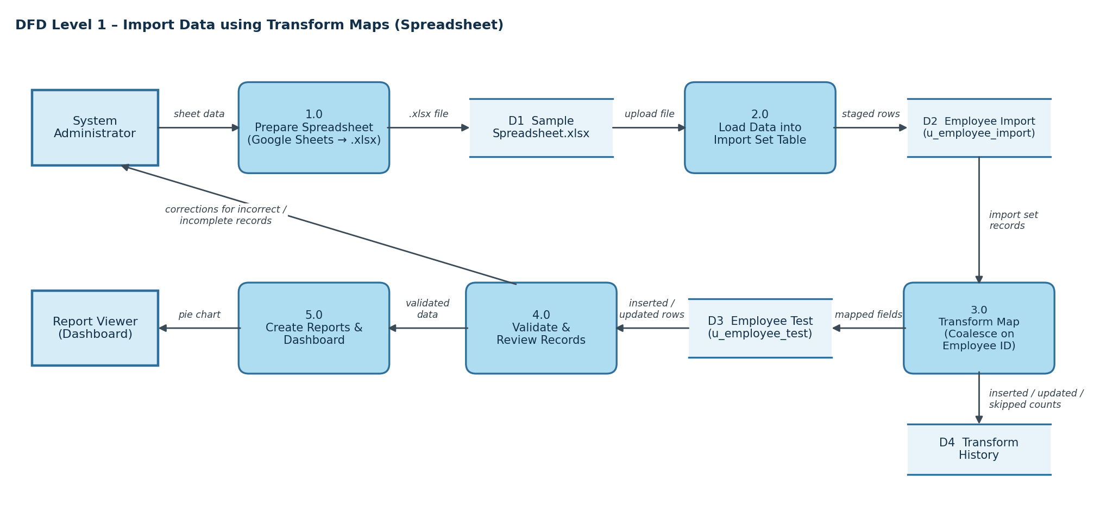
1. The administrator prepares sample employee data in Google Sheets and downloads it as Sample Spreadsheet.xlsx.
2. The file is uploaded with Load Data into the Import Set table, Employee Import (u_employee_import).
3. The Transform Map, Sample Spreadsheet Import, maps Employee ID, Name, Email, Department and Location to the Employee Test table (u_employee_test).
4. Coalesce on Employee ID updates existing records instead of creating duplicates; Transform History records the inserted, updated and skipped rows.
5. The imported records are validated and used to build the Employees by Department pie chart report, which is shown on a dashboard.

User Stories
Use the below template to list all the user stories for the product.
User Type | Functional Requirement (Epic) | User Story Number | User Story / Task | Acceptance criteria | Priority | Release
System Administrator | Spreadsheet & Table Setup | USN-1 | As an administrator, I can create a Google Spreadsheet with sample employee data (Employee ID, Name, Email, Department, Location) and download it in .xlsx format. | Sample Spreadsheet.xlsx is saved with all five columns filled in | High | Sprint-1
 |  | USN-2 | As an administrator, I can create a custom table, Employee Test (u_employee_test), and add the fields Employee ID, Employee Name, Email, Department and Location using Form Layout. | The new fields are visible on the Employee Test form after saving | High | Sprint-1
 | Import Set Table & Transform Map | USN-3 | As an administrator, I can load the spreadsheet through Load Data to create the Import Set table Employee Import (u_employee_import). | A success message is shown after submitting the import | High | Sprint-2
 |  | USN-4 | As an administrator, I can create the Transform Map Sample Spreadsheet Import (source: Employee Import, target: Employee Test) and use Auto Map Matching Fields. | Source and target fields are mapped correctly and the map is saved | High | Sprint-2
 |  | USN-5 | As an administrator, I can run the transform so that the staged data moves into the Employee Test table. | A success message is shown and the records appear in Employee Test | High | Sprint-2
 | Transform, Validate & Coalesce | USN-6 | As an administrator, I can review the imported records in the Employee Test list and rearrange columns using Personalize List Columns to validate the data. | Records are created and any incorrect or incomplete values can be identified | Medium | Sprint-3
 |  | USN-7 | As an administrator, I can enable Coalesce on the Employee ID field map so that duplicate records are not created. | Re-importing the same data updates existing records instead of adding duplicates | High | Sprint-3
 |  | USN-8 | As an administrator, I can load new data in Excel format into the import table (sheet number 1, header row 1) and run the transform again. | Transform History shows the inserted, updated and skipped counts; new IDs are added and changed rows are updated | Medium | Sprint-3
 | Reports & Dashboards | USN-9 | As an administrator, I can create a pie chart report, Employees by Department, on the Employee Test table, grouped by Department with Count as the aggregation. | The report runs, shows the count for each department and is saved | Medium | Sprint-4
Report Viewer |  | USN-10 | As a report viewer, I can see the Employees by Department report on a dashboard. | The report is displayed on the dashboard | Medium | Sprint-4

